MongoDB

Installation of MongoDB.

We need to download latest version of MongoDB from the MongoDB official site.

Ensure that proper version of Software is downloaded and kept ready.

Types of Installation

There are Two types of installation of MongoDB for Windows. They are

1. Interactive Installation
2. Unattended Installation

Installation of MongoDB for Windows

Ensure that the following file “mongodb-win32-x86_64-2008plus-ssl-3.4.9-signed” is available in the downloads folder.

Double click the file downloaded, A series of screens will appear that allows you through the installation process.

We can specify an installation folder, When we choose the “Custom” installation option.

It is a self-contained and does not have any other system dependencies. We can run MongoDB from any folder you choose. You may install MongoDB in any folder (e.g. D:\test\mongodb).

Environment Set up

MongoDB requires a directory to store all the data. By default, the path of the directory is Data\db prefixed with absolute path on the drive where you start MongoDB.

Create this folder by the following command:

Md \data\db

(or)

An alternate method of creating data directory is using –dbpath option.

Syntax:-

"C:\Program Files\MongoDB\Server\3.4\bin\mongod.exe" --dbpath d:\test\mongodb\data

Start MongoDB Server

To start MongoDB, run mongod.exe file from the command prompt.



To connect the MongoDB from client

To connect to MongoDB from the client Terminal, Type the following command

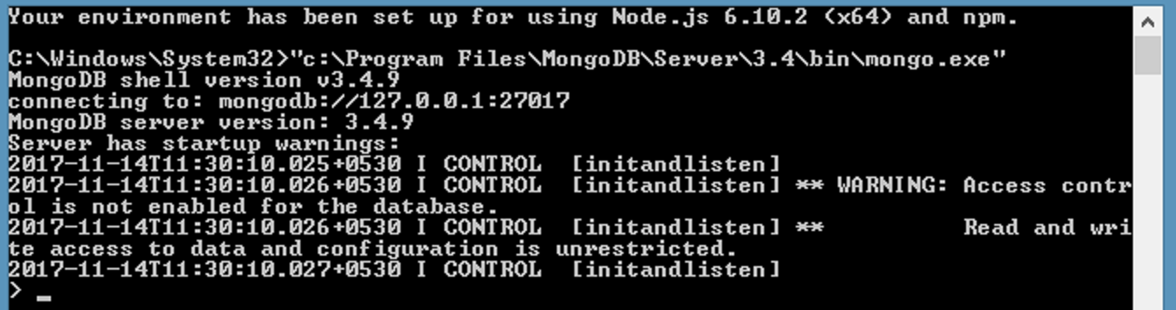

We can begin working with MongoDB.

To display all the Databases we use

* show dbs;

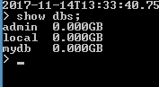

To display current active Database

* db

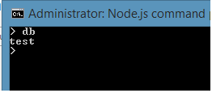

To use Database

* use mydb

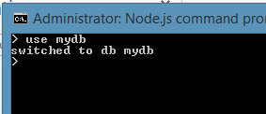

To create a collection we use the following command.

* Db.createCollection(“emp”);

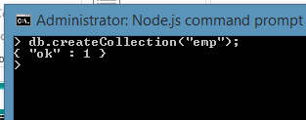

To print Collection statistics, use

* Db.printCollectionStats();

To delete a Collection, we use

* db.emp.drop()

